**DNA Sequencing chemistry guide**

PCR contaminants that affect cycle sequencing

Products carried over from the PCR amplification can affect cycle sequencing:

* **Excess PCR primers** compete with the sequencing primer for binding sites and reagents in the sequencing reaction . Additional primers in sequencing reactions using dye terminators result in the creation of multiple dye-labeled sequence ladders and noisy data .
* **Excess dNTPs** can affect the dNTP/ddNTP balance of the sequencing reaction, resulting in a decreased amount of short extension products .
* **Nonspecific PCR products** include primer-dimer artifacts and secondary PCR products . Nonspecific PCR products behave as templates in the sequencing reaction and cause the generation of multiple dye-labeled sequence ladders, which result in noisy data . Any significant quantity of nonspecific PCR products can cause poor-quality sequencing data .

Screen for nonspecific PCR products by running the PCR products on an agarose gel before sequencing . If you detect nonspecific PCR products, optimize and repeat the PCR amplification before sequencing . If you use a nested or semi-nested sequencing primer, you may obtain good sequence data . Alternatively, you can purify the desired PCR product directly from the agarose gel as long as the nonspecific PCR product is not the same size as the desired PCR product . However, significant contamination may remain because of incomplete separation .

Minimizing contaminants

To minimize the contaminants listed above, use the following strategies to increase the specificity of the PCR amplification:

• Optimize PCR through these parameters:

* Amount of starting DNA
* Careful primer design
* Primer concentration
* Enzyme concentration
* Magnesium ion (Mg 2+) concentration
* Nucleotide concentration
* Buffer composition
* Number of cycles
* pH
* Use manual hot-start method (if the enzyme does not have hot-start capability)
* Use AmpliTaq Gold™ DNA Polymerase as an automatic hot start
* Use the following master mixes:
* AmpliTaq Gold 360 PCR Master Mix
* AmpliTaq Gold Fast PCR Master Mix, UP (for use with the Veriti 96-Well Fast Thermal Cycler)

Purifying PCR products for sequencing

There are several methods for purifying PCR products . Select a method based on the amounts of components carried over from the PCR reaction and on the sequencing chemistry you plan to use:

* Ultrafiltration
* Ethanol precipitation
* Gel purification
* Enzymatic purification

**IMPORTANT!** If more than one PCR product is present, column purification, ethanol precipitation, or enzymatic purification will not isolate the desired product . Use gel purification to isolate the desired product or reoptimize the PCR to obtain a single product . Ultrafiltration may work if the contaminating PCR products are much smaller than the desired PCR product .

**Table 3. Commercial product for preparing PCR DNA templates.**

|  |  |  |
| --- | --- | --- |
| **Product** | **Source** | **Description** |
| ExoSAP-IT™ PCR Product Cleanup | Affymetrix | PCR cleanup to remove excess primers and unincorporated nucleotides . |
| ExoSAP-IT Express PCR Product Cleanup | Affymetrix | A 5-minute protocol that delivers the same superior cleanup result as the original ExoSAP-IT reagent . |

DNA template quality

Poor template quality is the most common cause of sequencing problems . Follow recommended procedures to prepare templates .

Results characteristic of using poor-quality templates:

* Noisy data or peaks under peaks
* No or low signal
* DNA template quality
* Early loss or termination of extension

Contaminants that affect sequencing

Contaminants in cycle sequencing reactions negatively affect polymerase binding and amplification or extension . Resulting sequences produce poor-quality data with low signal or high noise . Potential contaminants include:

* Proteins
* RNA
* Chromosomal DNA
* Excess PCR primers, dNTPs, enzymes, and buffer components (from a PCR amplification used to generate the sequencing template)
* Residual salts
* Residual organic chemicals, such as phenol, chloroform, and ethanol
* Residual detergents
* Agarose gel, if DNA was extracted from a gel

Examining DNA quality

Use both of the following methods to examine DNA quality:

* **Agarose gel electrophoresis**—Purified DNA should run as a single band on an agarose gel . Agarose gels reveal contaminating DNAs and RNAs, but not proteins .

**Note:** Uncut plasmid DNA can run as three bands: supercoiled, nicked, and linear . RNA contamination up to 1 µg can be tolerated, but it affects DNA quantitation greatly .

* **Spectrophotometry**—The A260/A280 ratio should be 1 .8 to 2 .0 . Smaller ratios usually indicate contamination by protein or organic chemicals . Spectrophotometry can reveal protein contamination, but not DNA or RNA contamination .

**Note:** Neither agarose gel electrophoresis nor spectrophotometry can reveal contaminating salts . Salts can interfere with the sequencing reaction, capillary electrokinetic injection, or electrophoresis, resulting in noisy data .

Cleaning up dirty templates

You can sometimes clean up a contaminated template with one of the following methods:

* **Ultrafiltration** (Microcon™ or Centricon™ filter units)—The most efficient method for salt removal . See EMD Millipore’s website ([**www.emdmillipore.com**](http://www.emdmillipore.com/)) for instructions on how to use the Microcon or Centricon filter units .
* **Spin columns**—May be used for salt removal .
* **Phenol/chloroform extraction**—Refer to [**Molecular Cloning: A Laboratory Manual**](http://www.cshlpress.com/pdf/sample/2013/MC4/MC4FM.pdf) [8] for detailed instructions .
* **Ethanol precipitation**—May be used for salt removal .

DNA template quantity

DNA template quantitation is critical for successful sequencing reactions . The most common way to determine DNA quantity is to measure the absorbance (optical density or OD) of a sample at 260 nm in a spectrophotometer .

Measuring UV absorbance

One OD is the amount of a substance, dissolved in 1 .0 mL, that gives an absorbance reading of 1 .00 in a spectrophotometer with a 1 cm path length . For DNA quantitation, the wavelength is assumed to be 260 nm unless stated otherwise . A260 values can be converted into µg/µL using Beer´s Law:

Absorbance (260 nm) = sum of extinction coefficient contributions x cuvette path length x concentration The following formulas are derived from Beer’s Law [16]:

* Concentration of single-stranded DNA = A260 x 33 µg/µL
* Concentration of double-stranded DNA = A260 x 50 µg/µL

**Note:** Absorbance measurements of highly concentrated (OD > 1 .0) or very dilute (OD < 0 .05) DNA samples can be inaccurate . Dilute or concentrate the DNA as needed to obtain a reading within the acceptable range .

Other methods

Applied Biosystems makes no specific recommendations on the use of these products for DNA quantitation:

* Fluorometric analysis using either Hoechst 33342 Fluorescent Stain or Invitrogen Quant-iT™ PicoGreen™ dsDNA reagent
* Fluorometric analysis using Invitrogen Quant-iT assays and the Qubit™ Fluorometer
* Measurement of UV-Vis absorbance using the Thermo Scientific NanoDrop 1000 Spectrophotometer, which does not require dilution for many sample types . If you have a real-time PCR instrument, you can use Applied Biosystems TaqMan™ RNase P Detection Reagents Kit (PN 4316831) to measure DNA quantity .

## DNA quantity

#### DNA template quantities

The amount of DNA template used in a sequencing reaction can affect the quality of the data . Too much template makes data appear top heavy, with strong peaks at the beginning of the run that fade rapidly . Too little template or primer reduces the signal strength/ peak height and increases the chance for dye blobs because a greater proportion of unincorporated dye molecules are left behind . In the worst case, the noise level increases so that bases cannot be called .

DNA sequencing reactions purified with the BigDye XTerminator Purification Kit result in high signal strength when analyzed on a DNA sequencer . When you prepare sequencing samples for purification with the BigDye XTerminator reagents, you may need to decrease the amount of DNA template in the sequencing reactions to keep the fluorescence signals on scale during analysis .

Table 6 shows the recommended quantities of DNA template for each sequencing chemistry and for samples purified with the BigDye XTerminator Purification Kit .

**Table 6. Recommended DNA template quantities for cycle sequencing.**

|  |  |
| --- | --- |
| **Template** | **Template Quantity** |
| PCR product : |  |
| 100-200 bp | 1-3 ng |
| 200-500 bp | 3-10 ng |
| 500- 1000 bp | 5-20 ng |
| 1000-2000 bp | 10-40 ng |
| >2000 bp | 40-100 ng |
| Single-stranded | 75-100 ng |
| Double-stranded | 200-500 ng |
| Cosmid, BAC | 0.5-1.0 ug |
| Bacterial genomic DNA | 2-3ug |

**The optimal quality and quantity of DNA**.

**Table 23. Reviewing DNA quality and quantity checklist.**

|  |  |
| --- | --- |
| **Recommendation** | **Comments** |
| Run an agarose gel to detect any contaminating DNA or RNA . | Purified DNA should run as a single band on an agarose gel .  **Note:** Uncut plasmid DNA can run as three bands: supercoiled, nicked, and linear . **Note:** RNA contamination up to 1 µg can be tolerated in the sequencing reaction, but it affects DNA quantitation greatly . |
| Measure the A260/A280 ratio of your samples . | For pure preparations of DNA (in TE), the  A260/A280 ratio is 1 .8 . For pure preparations of RNA (in TE), the ratio is 2 .0 . Very clean samples in pure water can give a ratio of 1 .5 to 1 .6 Smaller ratios may indicate the presence of protein or organic contaminants . Ratios less than 1 .8 may still produce high-quality results . |
| Quantitate the DNA template using the absorbance at 260 nm (A260) . | Quantitation by agarose gel electrophoresis may not be accurate because ethidium bromide incorporation is not consistent and the method of comparing the standard and sample brightness is subjective . |
| Dilute or concentrate the DNA as needed to obtain an A260 reading between 0 .05 and 1 .00 . | A260values below 0 .05 or above 1 .00 are not accurate because Beer’s law generally applies only within a certain concentration range . Outside of this concentration range, the relationship between absorbance and concentration is nonlinear . |
| Use the amount of DNA template in Table 6, “Recommended DNA template quantities for cycle sequencing .” .  Calculate the template concentration using the formulas . | Too little template can result in no or low signal . Too much template can result in top-heavy data . |
| Use the primer concentrations recommended 3 .2 pmol in a 10 µL reaction (dye terminator chemistry) .  Calculate the primer concentrations using the formula . | Too little primer can result in no or low signal . Too much primer can lead to overamplification of the 5X end of the template, resulting in top-heavy data . |

**Table: Reviewing primer design checklist.**

|  |  |
| --- | --- |
| **Recommendation** | **Comments** |
| Ensure that the primer has Tm >45°C . | If the Tm is too low, it may result in poor priming and low or no signal . |
| Ensure that primers are at least 18 bases long . | Primers that are too short may have Tms that are too low . |
| Ensure that there are no known secondary hybridization sites on the target DNA . | Secondary hybridization sites on the target DNA can result in double peaks throughout the sequence . |
| Choose primers that do not have runs of identical nucleotides, especially four or more Gs . | Runs of identical nucleotides in primers can cause n+1 or n-1 effects . Also, these primers may be more difficult to synthesize . |
| Choose primers with G-C content in the range of 30% to 80%, preferably 50% to 55% . | If the G-C content is too low, the Tm may be too low . If so, increase the primer length beyond 18 bases to obtain a Tm>45°C . |
| Design primers to minimize the potential for secondary structure and/or hybridization . | Primer-dimer formation from hybridization can result in mixed sequence at the beginning of the sequence .  Secondary structure in the primer, particularly at the 3X end, can result in poor priming and low or no signal. |
| Purify primers by HPLC to reduce the quantity of n-1 primers . | Primers containing contaminants or synthesized primers of the wrong length can cause problems in sequencing reactions, such as failed reactions, noisy data, or poor sequencing results . If the primer is a short oligo that contains n-1 primers, HPLC cannot always remove the n-1 contaminants . |

#### **Too many mixed bases called**

Too many mixed bases are called (analysis using the KB basecaller only)

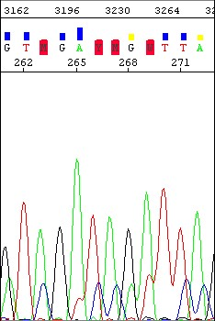

**Electropherogram**

|  |
| --- |
| **Possible cause(s) Recommended action** |
| **Biological cause** |
| Heterozygous insertion/deletion . Verify on reverse strand . |
| **Sequencing reaction issues (in individual samples or multiple samples)** |
| Secondary primer site in the template was Design a new sequencing primer .  sequenced . |
| Secondary amplification product in the PCR Use gel purification to isolate the desired product used as a sequencing template or product . For more information, see "Purifying template  contamination . PCR products for sequencing"  Design new PCR primers or optimize amplification parameters to obtain a single product . For more information, see "Preparing PCR DNA templates" on. |

|  |
| --- |
| **Possible cause(s) Recommended action** |
| **Sequencing reaction issues (in individual samples or multiple samples)** |
| PCR primers not completely removed from the Remove PCR primers completely before using PCR product used as a sequencing template . PCR products as sequencing templates . |
| Mixed templates . Review the DNA quality . |
| Sequencing primer contaminated with n-1 Resynthesize sequencing primer or purify by primer . HPLC or PAGE . |

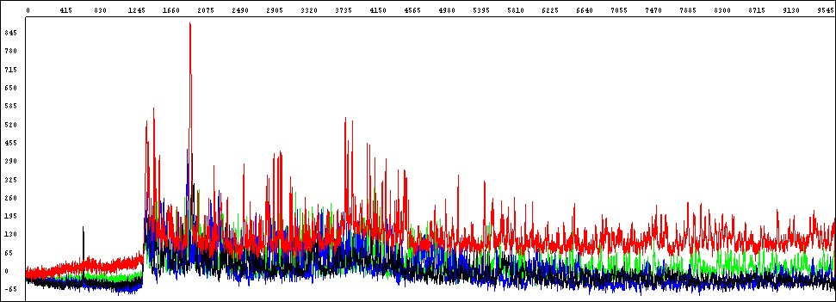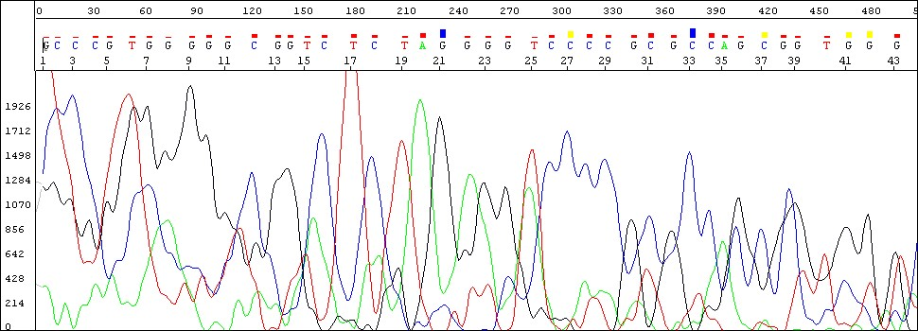

Low signal throughout

the entire sequence

**Electropherogram**

**Raw Data**

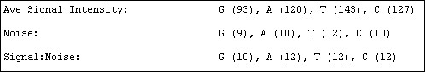

Annotation tab shows low average signal intensity

values for data from 3730 instrument

|  |  |
| --- | --- |
| **Possible cause(s)** | **Recommended action** |

**Possible cause(s) :** Sample contains salts from insufficient purification of templates, PCR products, or sequencing reactions with ethanol precipitation . Salts in the sample interfere with proper electrokinetic injection .

**Recommended action :** Review DNA quality, PCR purification, and sequencing reaction purification steps .

**Possible cause(s) :** Not enough primer or template in the cycle sequencing reaction .

**Recommended action :** Review DNA quantity (page 140) . Use the amounts recommended on page 55 . Run a DNA template control to check sequencing reaction quality (page 56) .

#### No signal

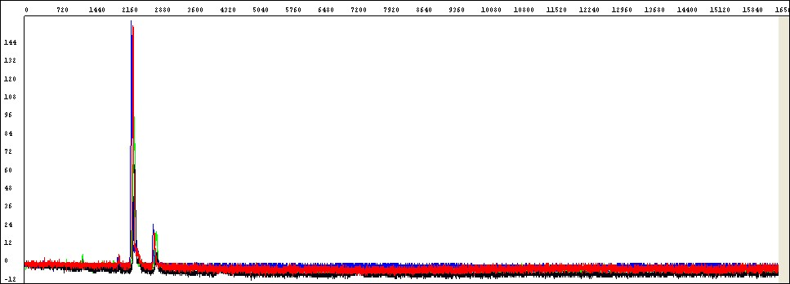

Flat signal profile

**Raw Data**

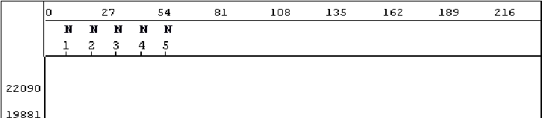

KB basecaller generated 5 Ns to indicate

a possible failed sequencing sample

**Electropherogram**

Unincorporated dyes

|  |  |
| --- | --- |
| **Possible cause(s) Recommended action** | |
| **PCR issues** | |
| PCR failure . Verify that a PCR product is present: perform  agarose gel electrophoresis . If amplicon is present (i .e ., clearly visible as a single band on agarose gel), perform sequencing trouble shooting (see below) . | |
| **Sequencing reaction issues (likely with multiple or all samples)** | |
| Loss of labeled product during purification of retaining extension labelled products . product during purification . | |
| Thermal cycler malfunction . Determine with the manufacturer how to test your thermal cycler for proper performance . | |
| One of the components of the sequencing Review the entire experiment carefully .  reaction (template, primer, or Ready Reaction 1 . Check the quantitation and quality of the Mix) was either omitted, was the wrong sequencing reaction components .  material, or was of poor quality .  2 . For each component, replace the  component, perform a sequencing run, then evaluate the results until you have identified the problem or replaced all of the reaction components .  3 . Run a DNA template control to determine whether the sequencing reaction failed or the template quality is low | |
| Insufficient template added to sequencing Check DNA quantitation and quality  reactions, leading to too few sequencing products generated during PCR . | |
| Template contains sequencing inhibitors such Follow recommended procedures to prepare as phenol . templates . Check DNA quality .  If necessary, clean up dirty templates . | |
| **Possible cause(s)** | **Recommended action** |
| No enzyme activity because Ready Reaction Mix was stored improperly or it separated upon storage . | Check the color of the Ready Reaction Mix . If the color is not uniform, the Ready Reaction Mix separated upon storage . Mix the Ready Reaction Mix gently before using it .  Run a DNA template control to test enzyme function . |
| Weak priming due to poor primer design . | Review primer design . Make new primers, then repeat the sequencing experiment . |
| Operator error: wrong sequencing primer used . | Use correct sequencing primer . |